Project Report on

BUS BOOKING SYSTEM USING (AWS)

Submitted in partial fulfillment of the requirements
of the degree of Bachelor in Engineering

by
Name of student | Class | Roll No.
Nikhil Bamane BE-4 13
Mohammad Bhanpurwala BE-4 14

Under the guidance of
Ms. Deepti Nikumbh



DEPARTMENT OF COMPUTER ENGINEERING
SHAH AND ANCHOR KUTCHHI ENGINEERING COLLEGE
CHEMBUR, MUMBAI – 400088.
2019 – 2020

Certificate

This is to certify that the report of the project entitled

BUS BOOKING SYSTEM USING (AWS)

is a bonafide work of
Name of student | Class | Roll No.
Nikhil Bamane | BE4 | 13
Mohammad Bhanpurwala | BE4 | 14
submitted to the
UNIVERSITY OF MUMBAI
during semester VIII in partial fulfilment of the requirement for the award of the degree of
BACHELOR OF ENGINEERING
in
COMPUTER ENGINEERING.

---------------------------------------
(Ms Deepti Nikumbh)
Guide

------------------------------------------ | ---------------------------------------
(Prof. Uday Bhave) | (Dr. Bhavesh Patel)
I/c Head of Department | Principal

Approval for Project Report for B. E. Semester VIII

This project report entitled BUS BOOKING SYSTEM USING (AWS)
by Nikhil Bamane, Mohammad Bhanpurwala is approved for semester VIII in partial fulfilment of the requirement for the award of the degree of Bachelor of Engineering.

Examiners
1.__________________________
2.__________________________
Guide
1.__________________________
2.__________________________

Date:
Place:

Declaration

We declare that this written submission represents our ideas in our own words and where others' ideas or words have been included, we have adequately cited and referenced the original sources. We also declare that we have not misrepresented or fabricated or falsified any idea/data/fact/source in our submission. We understand that any violation of the above will be cause for disciplinary action by the Institute and can also evoke penal action from the sources which have thus not been properly cited or from whom proper permission has not been taken when needed.
Name of student | Class | Roll No. | Signature
Nikhil Bamane | BE-4 | 13
Mohammad Bhanpurwala | BE-4 | 14

Date:
Place:

ABSTRACT

Public transport especially buses are getting crowded day-by-day due to heavy demand of transport facility. More over the frequency of the buses are unregulated. Either the buses lines up at one time or buses get delayed for a long time. This kind of chaos is mainly due to irregular Planning of bus intervals and not knowing the details of the number of passengers expected at a time. Hence, we are proposing a system in which the number of passengers which will be booking the bus can be calculated and the seats will be allotted accordingly. Cloud is the best platform to implement this system as the storage is dynamic in cloud and interface can be easily provided to people. It aims to discuss the implementation and designing of a Customer that can buy the bus ticket over the Internet, 24 hours a day throughout the week, this solves the issue of bus ticket being misplaced or stolen. Thus, this system is built up using cloud infrastructure for improved performance. In addition, PHP Hypertext Preprocessor (PHP) language was used for the front- end of the software while the back end was designed using MySQL and AWS for cloud storage.

TABLE OF CONTENTS

Chapter No. Title Page

1. Introduction 8
2. Literature Survey 9
3. Problem Statement 10
4. Implementation Details 11
4.1 Module and Description 13
4.2 Snapshot 15
5 Conclusion 21
6 References 22
LIST OF FIGURES
Figure No | Title | Page No
1 | Flow Chart | 11
2  3 | Admin Panel  User Panel | 12  12

INTRODUCTION
Currently, staff at the bus ticket counter is using an internal system to sell tickets at the counter and customers who are unable to buy bus ticket online at this moment would have to go to the counter to a buy bus ticket. Sometimes, customers’ needs to queue up a long queue to buy bus ticket and ask for information and this brings a lot of inconveniences to customers. The existing system of our public transit system has not been properly scheduled which leads to overcrowding of passengers in buses. This problem of crowding is mainly due to the unplanned bus management system. Our present Bus system does not account the total number of passengers in the bus stop. Here we are calculating the total number of passengers in a bus and regulate the bus service accordingly using dynamic resource allocation in cloud. This project is created to provide “safe, reliable, saving, efficient and affordable” services for user. This idea would help the user in a better way. As per the previous system the user had to do each and every process manually, but this system helps user to make the work bit faster. The user can then take print out of this bus ticket and use them. The bus ticket will be differed for different types of users. The number allotted for one person cannot be the same for the other. Hence, there is a need of reformation of the formal system with more advantages and flexibility. The present conventional method of ticketing is tedious. Since the volume of commuters is very high, manual ticket buying concept involves a lot of time, effort and manpower. This system is highly unsuitable when there is a huge rush of commuters and many times, lot of commuter’s fail to catch their buses. This is not only affecting the efficiency of people at their work place but also affecting them psychologically by less respect to co-passengers, staff members and at the end of the day at home. To improve the performance of system we have created a cloud-based system using AWS cloud as a web server and MySQL is used for creating database and PHP for server-side scripting.

LITERATURE SURVEY
Currently, the type of system being used at the counter is an internal system which is manually used in selling the bus tickets [2]. The problems facing the company are that customers have to go to the counter to buy bus ticket or ask for bus schedule, customers will also have to queue up for a long time in order to secure a bus ticket and will also need to pay cash when they buy the bus ticket [3]. With wide use of internet, a lot of online shopping, online business, and online booking websites are developing to ease the user to do their work- User just need to use few fingers click then can buy all the things their need to [1]. With this few finger click user not need to queue up for a long time to pay for the goods at the cashier. Nowadays, a lot of website about online services or online ticketing system can be found. For Booking, we can only use their system to check the time, date, and destination of the ticket, but we cannot reserve the ticket online [4]. We have to go to their counter or agent and buy the ticket manually. They did not provide service or system as Plus liner or Mara liner. That is the weakness in the current system for Transnational. Thus we are trying to overcome this problem in our system [6]. Electronic tickets, or e-tickets, gives evidence that their holders have the permission to enter a place of entertainment, use a means of transportation, or have
access to some Internet services. The design of this online system will be beneficial to the customer because it has not existed before [1]. However, Online Bus Ticket Reservation System enables the customer to buy bus ticket, make payment, and ask for information online easily. Furthermore, staff can sell bus ticket using Bus Ticket Reservation System after checking the bus ticket availability for the customer and print the bus ticket to the customer [2]. The Existing system still uses the non-efficient way of ticketing. As the entire data will be saved on a Firebased cloud, it will be helpful for the Bus Organization in the future for increasing the use of public transportation [1]. This Project Application will be useful for the Local People as well as Bus Organization. The Passenger will be able to save his time as he will get the current location of the bus of his required destination. Also our Application provides cash- less transaction. As all the information will be stored on a cloud it will be helpful for the Bus Organization. Our application provides many facilities that will help to increase public means of transportation [4].

PROBLEM STATEMENT
Nowadays, the system that are using by the staff at the counter currently is an internal system and just used to sell the bus ticket at the counter. Customer has to go to the counter to buy bus ticket or ask for bus schedule. Furthermore, customers need to pay cash when they buy the bus ticket and sometimes needs to queue up long time to get the bus ticket. The main objective of this Project on Bus Booking system is to manage the information of Bus, Tickets, Booking, Customer details, Bus routes, Seat availability and much more. Admin has full control of the system; all the main functions are to be performed from Admin panel.

IMPLEMENTATION DETAILS
Flowchart:

START

SIGN IN
NO
ENTER DETAILS
LOGIN SUCCESSFULL

IF VALID
USER
YES

SIGN UP

SUBMIT SIGNUP

Fig 1. Flowchart diagram for User login and Sign up.

ADMIN
ACCEPTS

BOOKINGS
ROUTES
CUSTOMERS

AVAILABLITY
SEATS
BUSES

Fig 2: Admin Panel

USER
SELECTS

BOOKINGS
ROUTES
CUSTOMERS

AVAILABLITY
BUSES
SEATS

Fig3: User Panel

Module:
Login Module
In this module we have Sign Up/Sign in page where we can insert our credentials in it by selecting the option. After successful sign up you can add your (Username, Password) also you can check box to save the password and click sign in to enter.

Admin Dashboard Module
This module navigates you to desired option. Here you can click on the icon to get the information of specific data field represented example select customers to get information regarding customers.

Customers Module
Here you can view all customers also add new customer by clicking the ‘ADD NEW’ button. You can select check box next to customer to perform any operation also you can select ‘FILTER’ to filter the customers.

Booking Module
Here you can select BOOKING to get all the entries of bookings and view all the booking with customer name also can add new booking using ADD NEW button.

Buses Module
Here you can select BUSES to get all the entries of buses and view all the buses with their name also can add new bus using ADD NEW button.

Availability Module
Here you can select AVAILABILITY to get all the entries of availability on a specific date and view all the availability with their information on date, bus, and time also you can add new availability using ADD NEW button.

Routes Module
Here you can select Routes to get all the routes of buses and view all the routes with their name also admin can add new route using ADD NEW button.

Description:
Admin has full control of the system; all the main functions are to be performed from Admin panel. Customer’s information such as ID, Full name, phone number and Id number is included in this section. For bus bookings, he/she has to provide Id number, full name, phone number, select bus, seat number, date, and select whether the customer carries luggage or not. Buses and Seats are also added using the system. While adding seats the user just has to provide seat number After all these, the customer has to check for bus availability which is also maintained by the admin. To maintain bus availability, he/she has to select bus, route, date, departure time and maintain status. Another feature of Bus booking system is Routes details. To add a route detail, he/she has to route name with time and amount. The admin can view summary reports such as availability reports, routes, status, booking reports, customers, and seat report. Just like the admin dashboard, the customer login also has same responsive dashboard as of admin. The difference is that customer cannot use full system. A customer can make bookings, check buses, routes, seats, and availabilities. We used AWS to store our database online and provide services to our customers 24*7 along with Putty, Vesta and FileZilla.

Snapshots:
Login
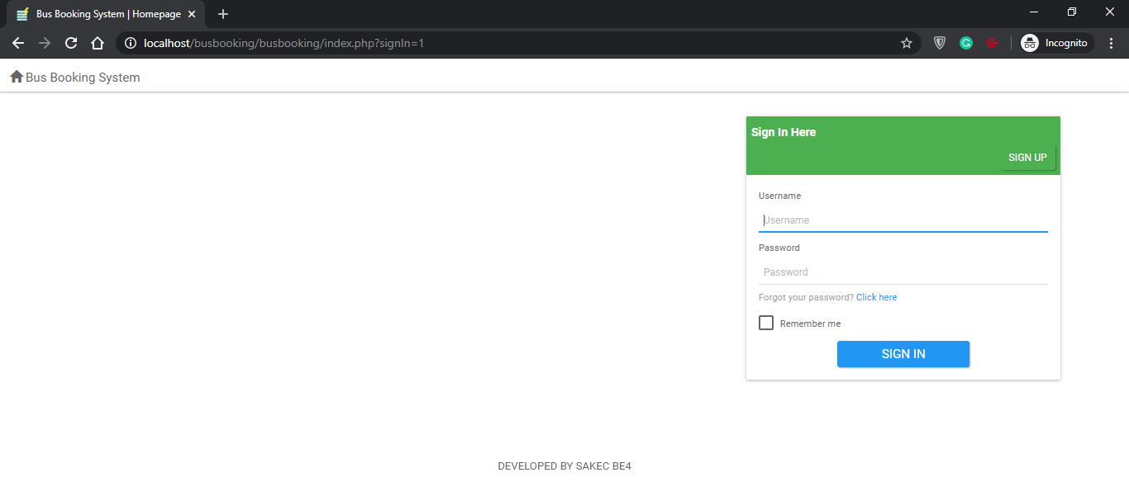
1. Sign Up/Sign in.
2. Click on appropriate field to add credentials.
3. Fill all the fields (Username, Password)
4. Click Check box to save the password.
5. Click Sign in to enter
Admin Dashboard
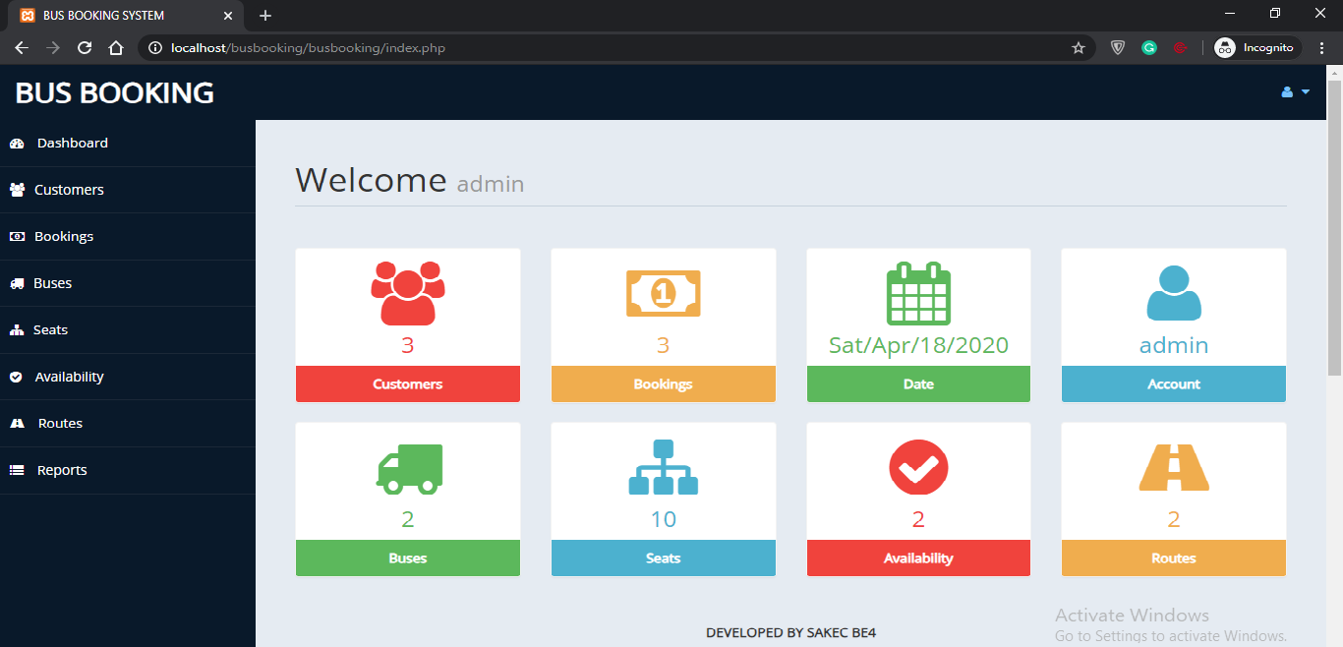

1. Navigate to desired option.
2. Click on the icon to get the information of specific data field represented by icon.
3. Select Customers to get information regarding customers.
Customers
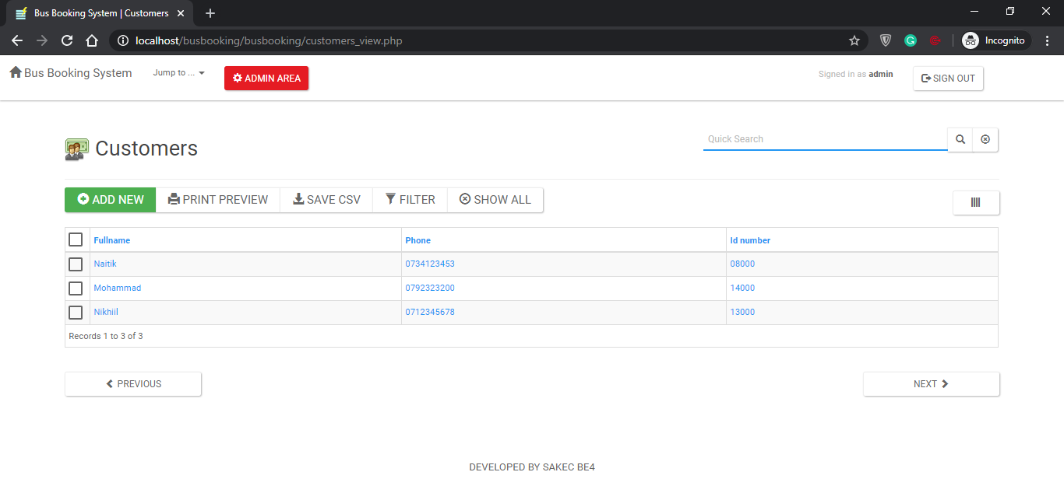

1. View all customers
2. Add new customer by clicking the ‘ADD NEW’ button.
3. Select check box next to customer to perform any operation.
4. Select ‘FILTER’ to filter the customers

Booking
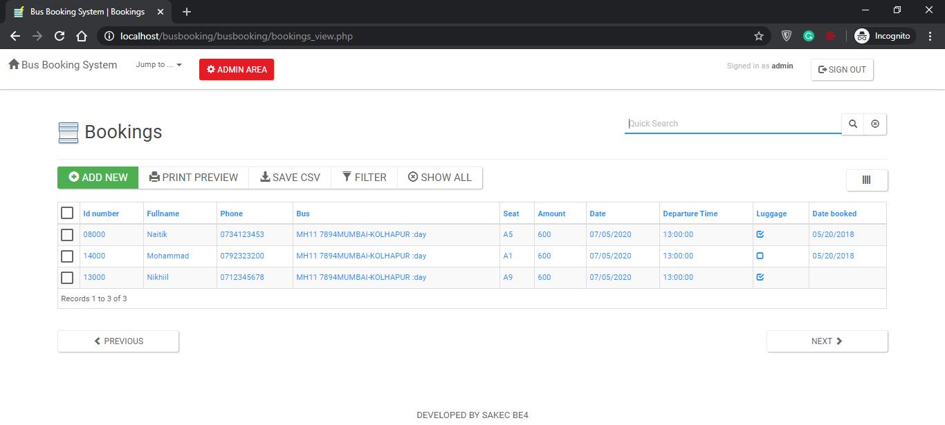

1. Select BOOKING to get all the entries of bookings
2. View all the booking with customer name.
3. You can add new booking using ADD NEW button

Buses
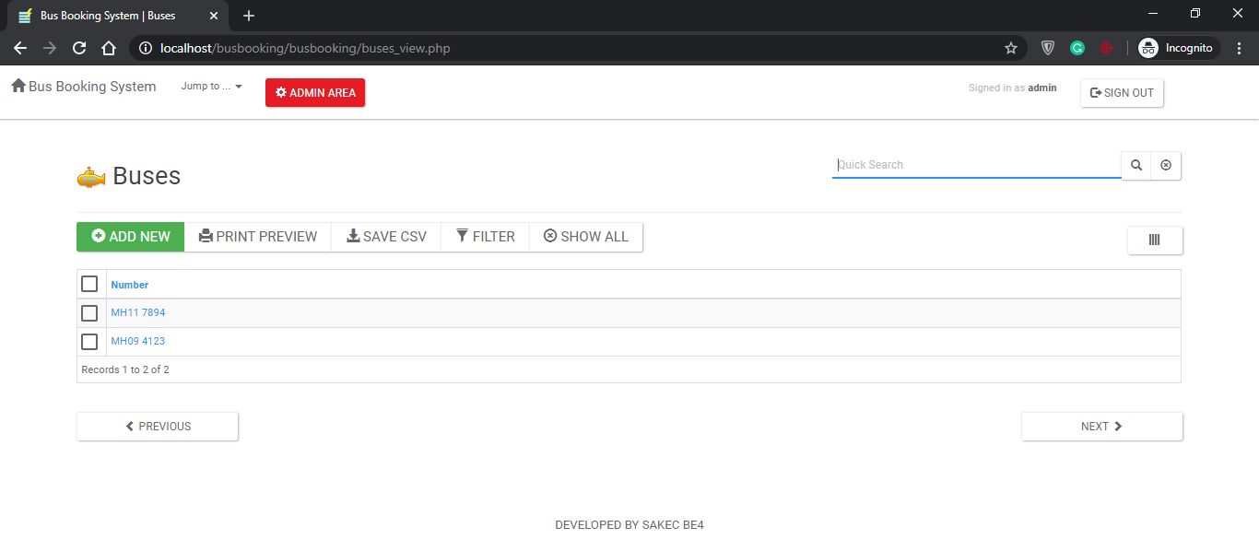

1. Select BUSES to get all the entries of buses
2. View all the buses with their name.
3. You can add new bus using ADD NEW button

Availability
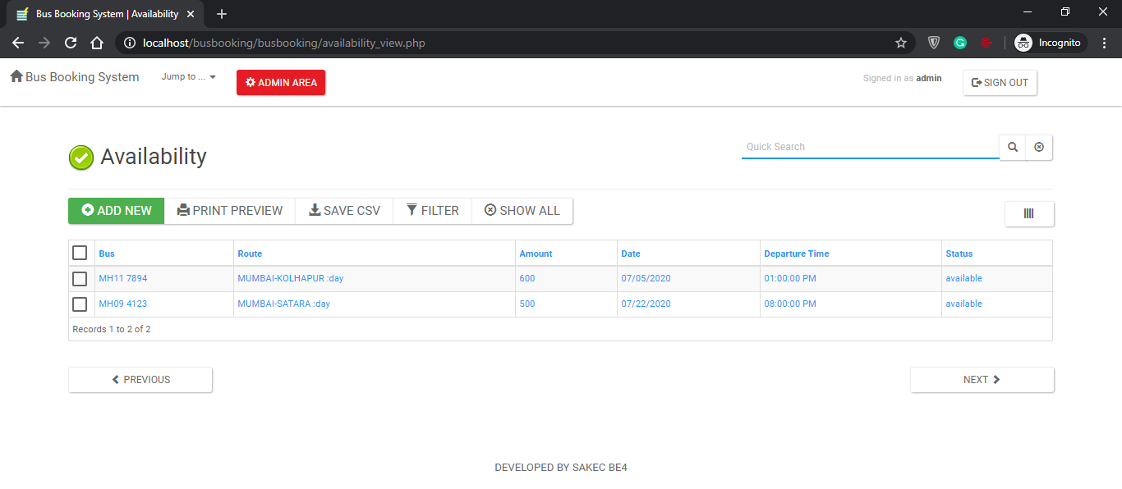

1. Select AVAILABILITY to get all the entries of availability on a specific date.
2. View all the availability with their information on date, bus, and time.
3. You can add new availability using ADD NEW button.

Routes
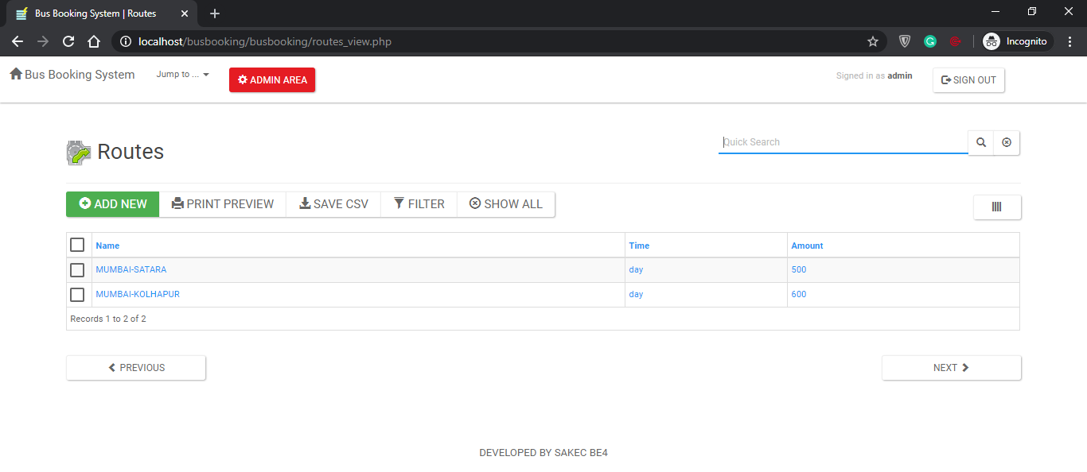

1. Select Routes to get all the routes of buses
2. View all the routes with their name.
3. Admin can add new route using ADD NEW button

Deployment:

AWS Instance
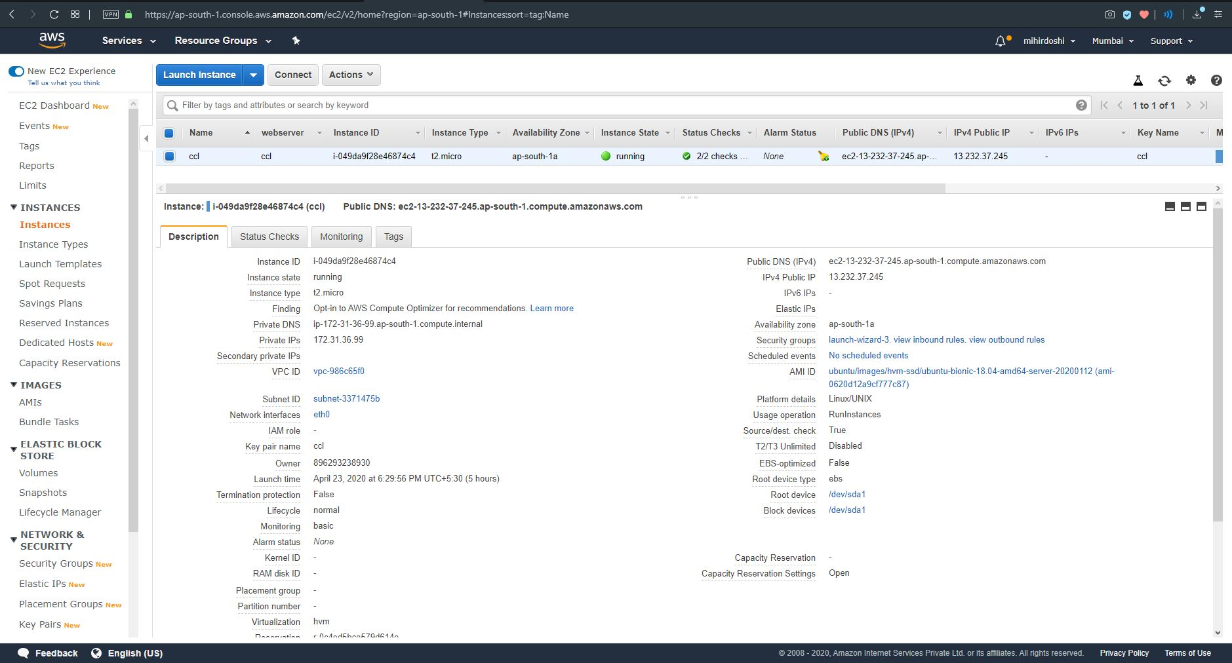

It provides scalable computing capacity in the Amazon Web Services (AWS) cloud.
Putty
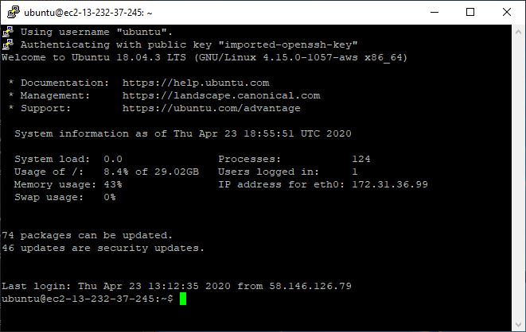
It is a free and open-source terminal emulator which supports several network protocols, including SCP, SSH, Telnet, rlogin, and raw socket connection.

Vesta Control Panel
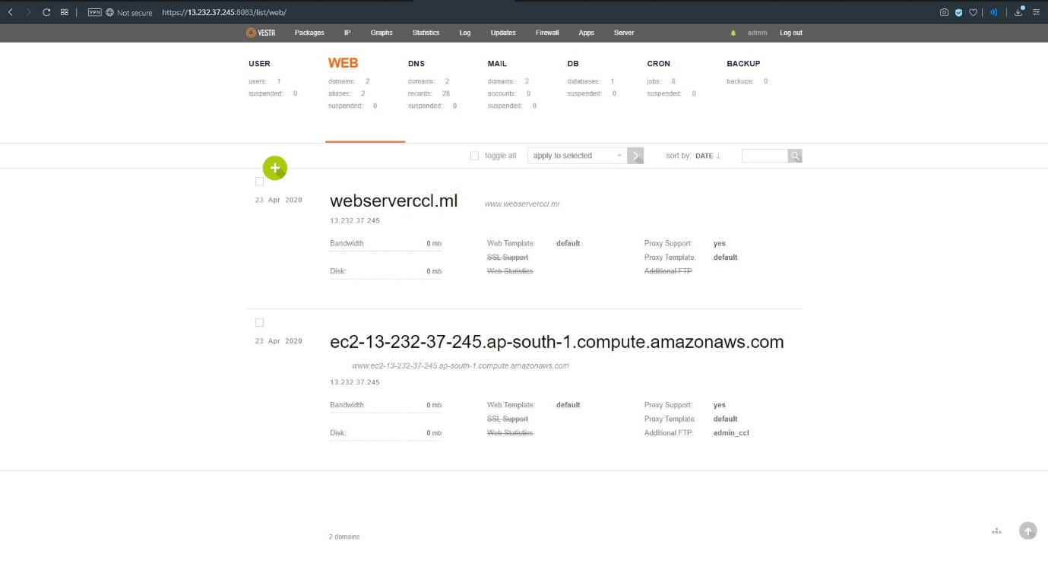
It is an open source hosting control panel, which can be used to manage multiple websites, create and manage email accounts, FTP accounts, and MySQL databases.

FileZilla
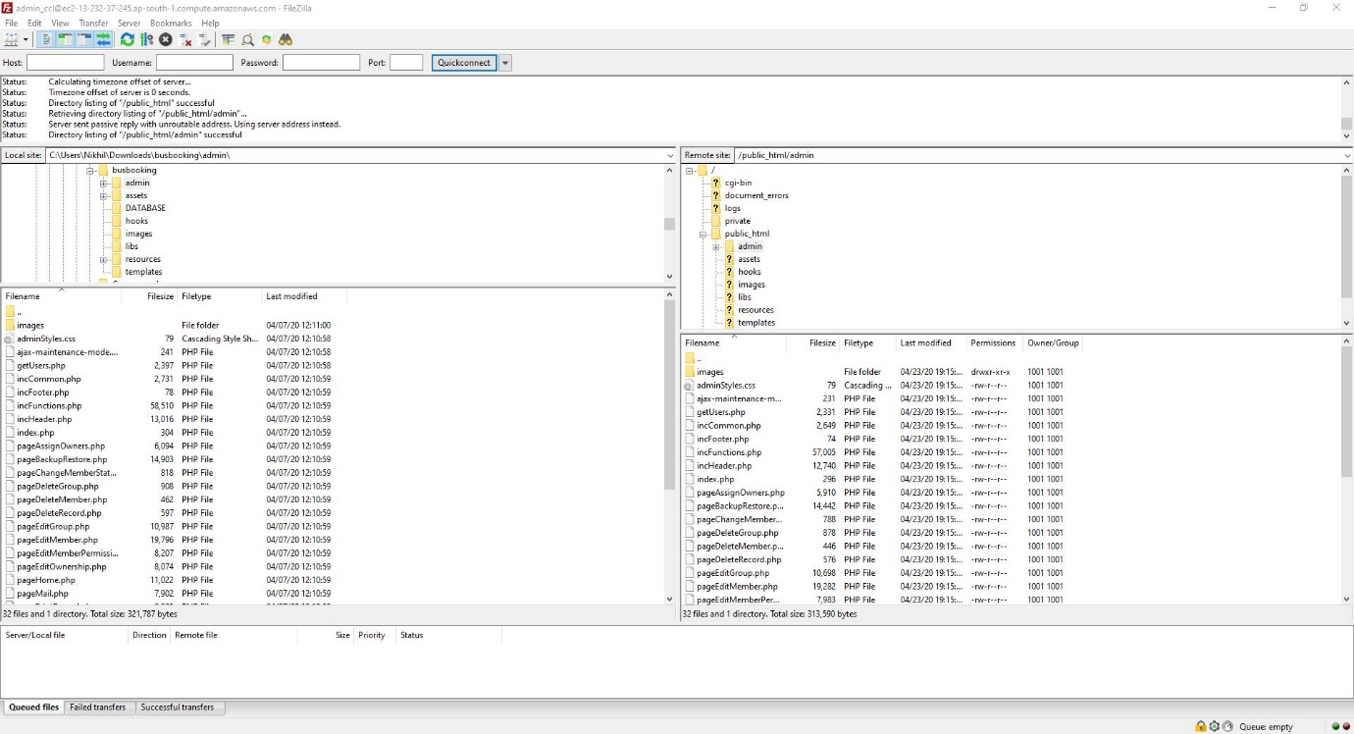
FileZilla is a powerful and free software for transferring files over the Internet. It is a very popular FTP client.

PhpMyAdmin
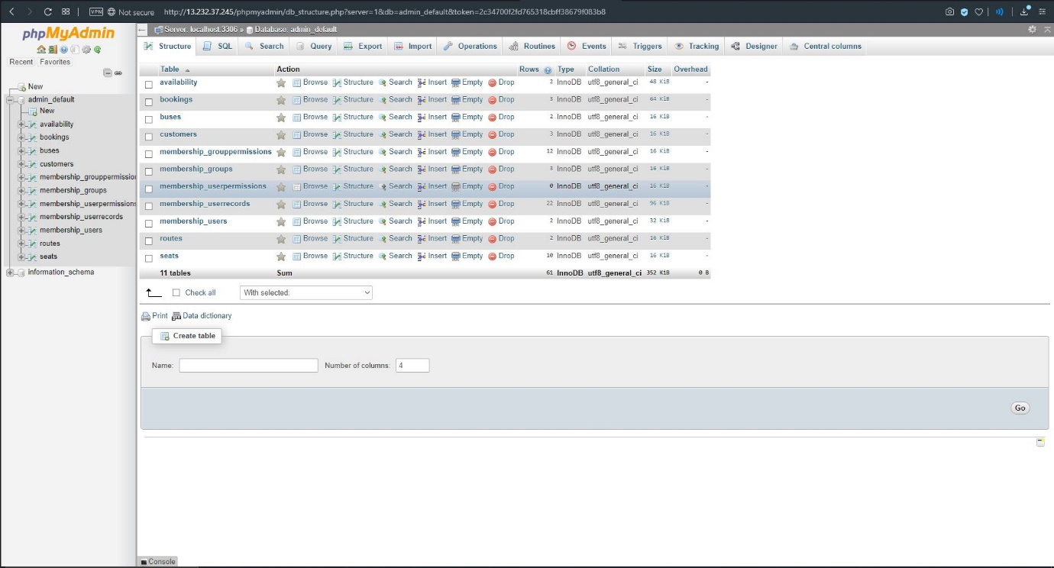

CONCLUSION
Nowadays, bus agencies are taking important role in transportation, and to make reservation reliable they need a strong system that they will make reservation easier, faster and safer. This project designed to meet requirements of a bus reservation system. It has been developed in XHTML, PHP, CSS, JAVA SCRIPT and database has been built in MySQL for cloud storage we have used AWS along with Putty, Vesta, FileZilla. By using this application, the company can provide reservation services and information to their customers without the limitation of office hours or manpower. Not only does it let customers book trips around the clock from any location with an internet connection but it is also designed for use by the company to internally manage their business processes; minimizing human errors and overcoming difficulties and problems that arose in the previous system.

REFERENCES
[1] M. A. HANNAN, A. M. MUSTAPHA, A. HUSSAIN and H. BASRI.
“Intelligent Bus Monitoring and Management System”. Proceedings of the World Congress on Engineering and Computer Science 2012 Vol II WCECS 2012, October 24-26, 2012, San Francisco, USA

[2] Oloyede, M.O. 1 *, Alaya S.M. 2 Adewole, K.S 3. “Development of an Online Bus Ticket Reservation System for a Transportation Service in Nigeria”. Computer Engineering and Intelligent Systems ISSN 2222-1719 (Paper) ISSN 2222-2863 (Online) Vol.5, No.12, 2014.

[3] Sharmin Akter, Thouhedul Islam, Rashidah F. Olanrewaju, Ajayi Adeniyi Binyamin. “A Cloud-Based Bus Tracking System Based on Internet-of-Things Technology”. 2019 7th International Conference on Mechatronics Engineering (ICOM).

[4] Vinayak Nair, Amit Pawar, D. L. Tidke, Vishakha Pagar and Nikita Wani. “Online Bus Tracking and Ticketing System”. MVP Journal of Engineering Sciences, Vol 1(1), DOI: 10.18311/mvpjes/2018/v1i1/18297, June 2018.

[5] Filipe Araujo, Marilia Curado, Pedro Furtado, Raul Barbosa. “Taking an Electronic Ticketing System to the Cloud: Design and Discussion”. 2014 IEEE International Conference on Big Data.

[6] Nwakanma Ifeanyi Cosmas, Etus C, Ajere I.U. & Agomuo Uchechukwu Godswill. Online “Bus Ticket Reservation System”. IIARD International Journal Of Computer Science And Statistics Vol. 1 No.2, 2015 www.iiardonline.org

